Customer Shopping Behaviour Analysis Report

1. Project Overview
This project focuses on analyzing customer shopping behaviour using transactional and demographic data to understand purchasing patterns, customer preferences, and revenue contribution.
The analysis integrates Python (EDA), SQL (data querying), and Power BI (visual analytics) to transform raw customer data into meaningful business insights.
The final outcome is an interactive Customer Behaviour Dashboard that highlights:
Customer base size
Purchase behaviour
Review ratings
Subscription trends
Revenue and sales distribution across categories and age groups.

2. Dataset Summary
The dataset contains customer-level shopping information where each record represents a purchase made by a customer.
Key Columns in the Dataset:
- customer_id – Unique identifier for customers
- age_group – Age categories of customers
- gender – Male / Female
- category – Product category (Clothing, Accessories, Footwear, Outerwear)
- purchase_amount – Amount spent per purchase
- review_rating – Customer feedback rating
- subscription_status – Yes / No
- shipping_type – Shipping preference
- frequency_of_purchase – Purchase frequency
- Overall Dataset Metrics (from Dashboard)
- Total Customers: 3.353K
- Average Review Rating: 3.76
- Average Purchase Amount: $59.61

3. Exploratory Data Analysis (EDA) Using Python

EDA was performed using Pandas, NumPy, Matplotlib, and Seaborn to understand data distribution, trends, and relationships.
EDA Process:
- Data Cleaning
- Checked missing and null values
- Removed duplicates
- Standardized category and age group labels
- Statistical Analysis
- Mean, median, and distribution of purchase amount
- Rating distribution analysis
- Visualization
- Category-wise purchase trends
- Age group vs revenue comparison
- Subscription vs non-subscription behaviour
Key EDA Findings:
- Most customers provide ratings between 3.5 to 4, indicating good satisfaction
- Middle-age groups show higher purchasing consistency
- Non-subscribed customers dominate the dataset
- Clothing and accessories show strong purchase frequency

4. Data Analysis Using SQL
SQL was used to perform structured queries for extracting business insights.
Key SQL Operations:
- Customer count analysis
- Category-wise revenue calculation
- Subscription-based customer segmentation
- Age group–wise performance evaluation

Sample SQL Queries:

SELECT COUNT(DISTINCT customer_id) AS total_customers
FROM customer_data;

SELECT category,
SUM(purchase_amount) AS total_revenue
FROM customer_data
GROUP BY category;
Copy code

SELECT subscription_status,
COUNT(customer_id) AS customer_count
FROM customer_data
GROUP BY subscription_status;

*Insights from SQL Analysis:
- Non-subscribers (~79%) form the majority of customers
- Subscribed customers contribute relatively higher average spending
- Clothing category generates the highest revenue and sales.

5. Dashboard Analysis
Key Performance Indicators:
- Number of Customers: 3.353K
- Average Review Rating: 3.76
- Average Purchase Amount: $59.61
- Subscription Status Analysis
- Subscribed Customers: ~21%
- Non-Subscribed Customers: ~79%
➡ This indicates strong potential to grow revenue through subscription-based offers.
Revenue by Category
- Clothing contributes the highest revenue
- Accessories follow as the second-highest revenue generator
- Footwear and Outerwear show lower revenue contribution
Sales by Category
- Clothing records the highest number of sales
- Accessories have moderate sales volume
- Footwear and outerwear show limited demand

Revenue by Age Group
- Middle-age groups contribute the highest revenue
- Younger and older age groups show comparatively lower spending
Review Rating by Age Group
- Ratings are fairly consistent across age groups
- Older age groups tend to give slightly higher ratings

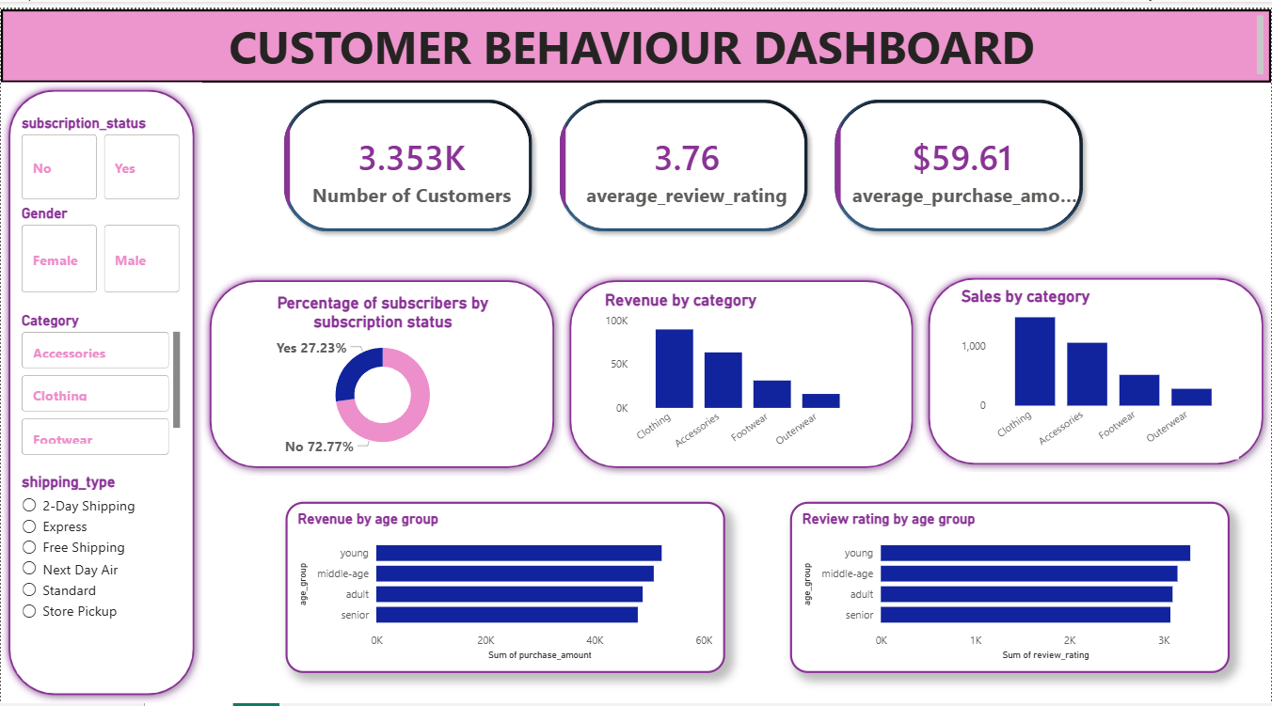

6. Business Recommendations
Based on the analysis, the following recommendations are suggested:
- Increase Subscription Adoption
- Introduce loyalty rewards and exclusive discounts
- Offer free shipping or early access for subscribers
- Focus on High-Performing Categories
- Expand clothing and accessories inventory
- Run targeted promotions on best-selling products
- Age-Based Marketing Strategy
- Target middle-age customers with personalized offers
- Design budget-friendly deals for younger customers
- Improve Low-Performing Categories
- Bundle footwear and outerwear with popular items
- Offer seasonal discounts
- Enhance Customer Satisfaction
- Analyze low review ratings to improve product quality
- Improve delivery speed and return policies

7. Conclusion
This project demonstrates how EDA using Python, data analysis using SQL, and interactive visualization using Power BI can be combined to Analyze customer shopping behaviour effectively.
The dashboard provides clear insights into customer preferences, revenue drivers, and subscription patterns, enabling businesses to make informed, data-driven decisions.

